BLOG

Introduction: -

Our project is X-Pharm, which is also the name of our online pharmaceutical website. We will deliver the medicines from physical pharmacies to the customers’ doorstep. Our goal is to make things easier, comfortable, and faster for the customers. We will always try to offer a much wider range of options than a traditional pharmacy. It is not possible to find every medicine in a physical pharmacy but due to the wider range of medicines in online pharmacies, getting a specific kind of medicine is easier.

Purchasing medicines in an online mode provides greater convenience, especially to the people who aren’t able to go to the pharmacy by themselves or those who just want to make their lives a bit easier.



Practical Aspects: -

So, Here at X-Pharm what basically we are trying to is to make the lives of all those people who are currently under home-isolation as they are under-going Covid-19 a little easier.

As, when someone is under home isolation due to any medical reason, they all require pharmaceutical products on a daily basis to help them recover from any disease/condition they are currently suffering from.

In a Gist X-Pharm is basically an online platform which provides door-to-door services to its customers when they order any pharmaceutical products as it gives the society more than one benefits as it first helps the patients to get their medicines delivered to their door steps and the second one is that it also helps in reducing the spread of covid-19 as then the customer doesn’t have to go out to their local medical stores and have a risk of spreading/catching Covid-19.

Our Team Came up with this idea during the peak of 2nd wave of Covid-19 in India, as the lock-down was implemented again during that period of time. But Sadly, we could not pursue this project during that time as some of our team mates got infected by the virus.

First of all I want to Thank Mr. Shashank Sir and Mr. Anuragh Sir for giving us this opportunity again pursue this project and a chance to help people in any way possible. Hence, After hearing about this opportunity we all got together again and fixed a time-line as soon as we could.

Why We Chose This Project: -

Our project is for the betterment and enhancement of medical services. It provides you with all your requirements of medicines and necessary items related to the medical field. If someone wants to buy medicines or any other pharmaceutical items, the person can just go to our website, create an account, look for the medicine he wants and simply order it. Especially for COVID-19 patients, who are quarantined at home and are unable to visit their local pharmacy to fulfil their pharmaceutical needs. It will minimize the customer's work and will help them in saving a lot of time which they can use to do other important things.

.As we all know that in our current pandemic situation some places are in lockdown or in quarantine, and they have an urgent need of medicine, one of our batch mates, many of our relatives and friends has faced this issue, so keeping that in mind we have chosen this project, and this will also help the non-COVID infected patients by saving their time in their need to procure medicine. We have always wanted to help our community, and we think that this project is an apt way of doing this. We also chose this project to learn how to make websites and develop our skill set.

Our Timeline & Way of Approach: -

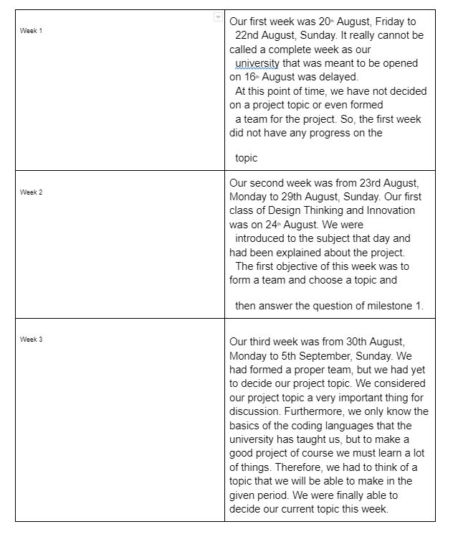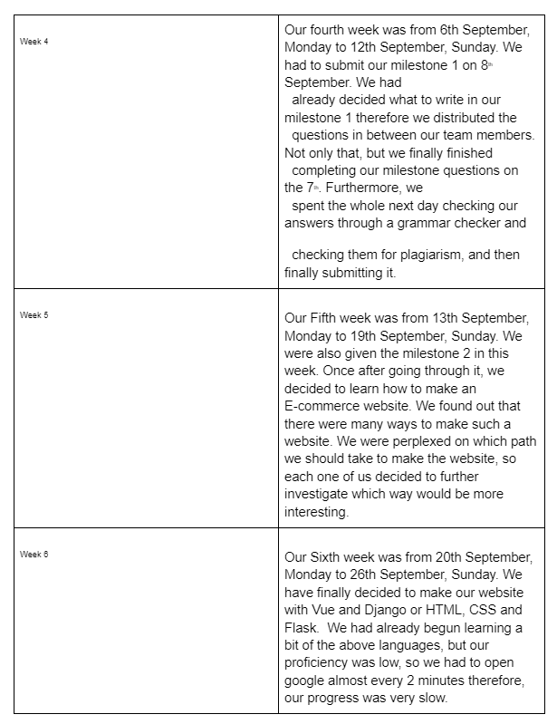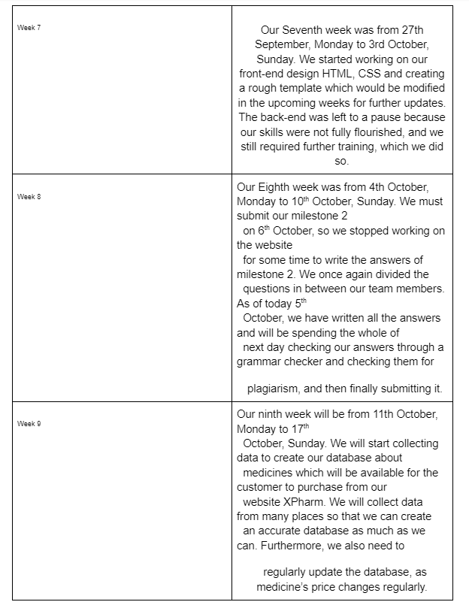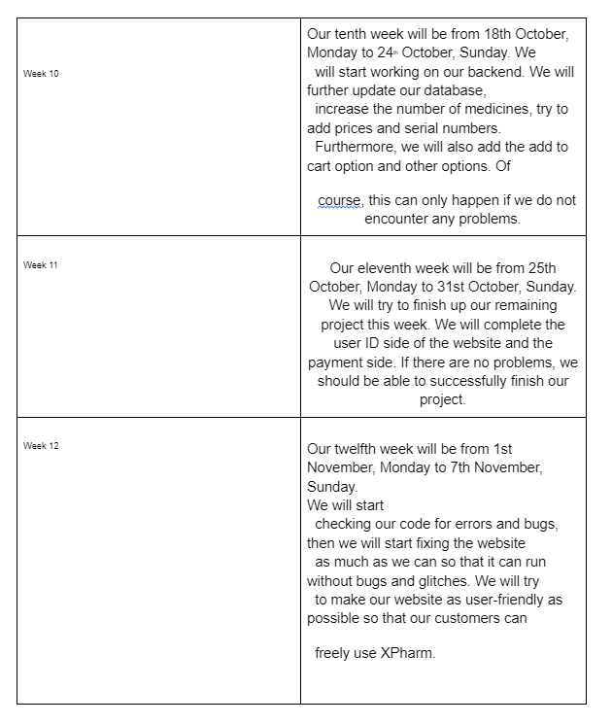

So, here is our tentative deadline according to which we completed this project from the start.

Hence, after all these 12 weeks of work our team is finally ready to take this project live on the market and release it for public, we are only waiting for our domain to get accepted and registered.

Cost Estimation After Release of Our Project: -

Since we are in the deployment phase our area of pursuit will be limited only to the local level at the beginning which may be expanded to the district level or further depending upon the feasibility and market conditions at that point of time.

Following are the estimated cost for deploying our project into the market within our budget after subtracting the profits and adding the losses: -

Labour cost: ₹3-5 lakh (per annum for district)

Transportation charges: ₹1-1.5 lakhs (per annum)

Material: ₹70,000 per annum

Maintenance charges: ₹1-5 lakh per annum

Services tax: ₹50,000 approx. (per annum)

Software: domain charges = ₹10,000-22,000 per annum, web hosting + server charges = ₹12,000 per annum

Total Software Charges = ₹20,000-35000

 Hardware: \*\*\* NA \*\*\*

Why 

Challenges Faced During Our Completion: -

The PROJECT is challenging because it requires deep knowledge of JavaScript, HTML, Flask (Frame work of Python) & MySQL. We also must learn all these languages in order to make our project, which will consume a large proportion of the time. We also must create a database of medicines for the website. Since the database of medicines will be huge it will take some time to gather all the data which can ultimately delay the project. We also do not have any prior experience in making websites, therefore it will be challenging enough to make this a project that can take four months. Therefore, the PROJECT can be done in four months as we need to sharpen our skills that are required for the development of this project.

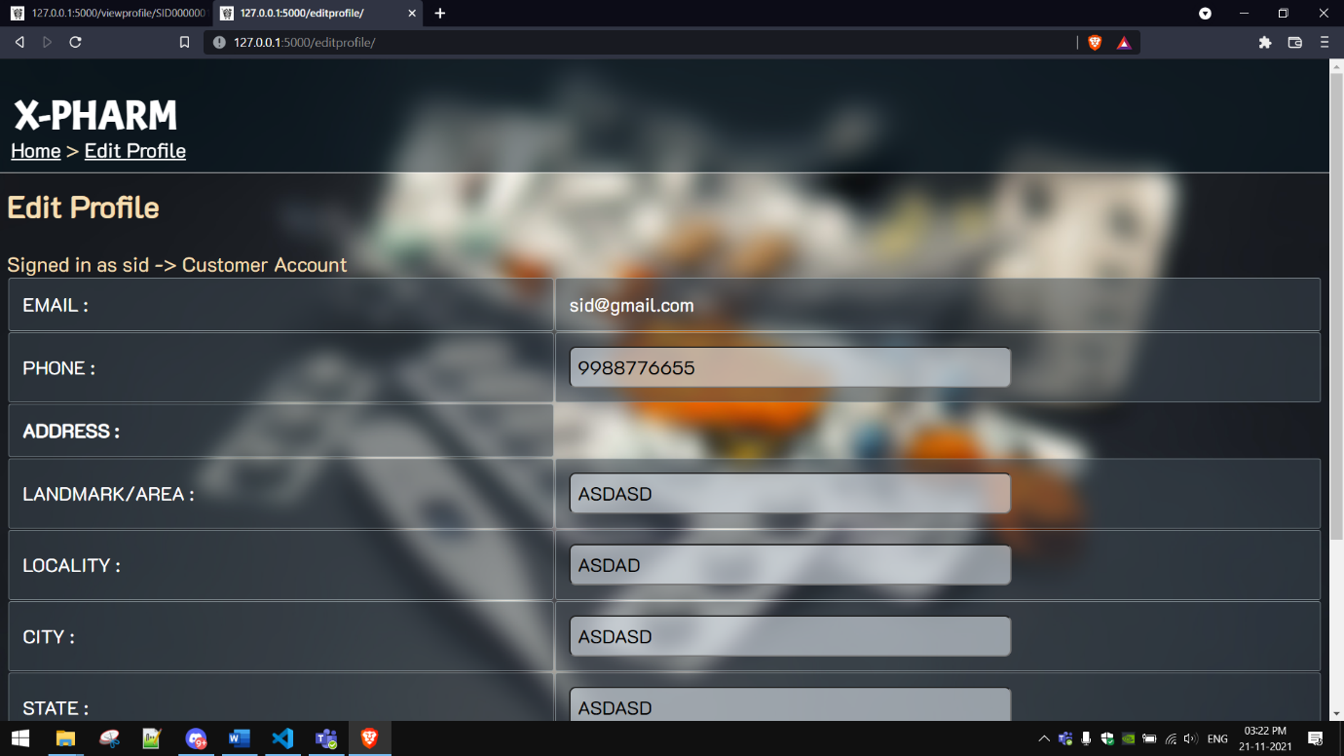

We fulfil a lot of legal norms that are related to an online pharmacy website, such as being authorized to sell medicine in retail by the government. We also provide information about the medicine and offer written advice about the medicine on the website. An ethical issue that can happen with our project is that we may accidentally provide counterfeit medicine or medicine that is past its expiry date, this will cause a lot of problems with the patient who has ordered the medicine from our website. Of course, this is an entirely hypothetical situation, but there is a chance of it occurring due to human error. Although, this will cause the customer to lose trust in our website.

Considering the scale of the project, facilities like computers with any operating system

which can access the internet and presence of Python 3.5 or greater is a must, henceforth

modules such as Django and flask as and when needed. Since the project mainly focuses on the website part JavaScript will play a crucial role. Finally, to create a catalogue of medicines, a list which consists of important information like uses, components, Cautions, Directions,

and Side effects will be collected as a dataset and then further actions will be taken.

Potential Clients for Our Website

The potential clients of our website will be people who have been infected by the coronavirus who are quarantined and people who are in lockdown. These people are our target audience because they cannot leave their homes to visit their local pharmacy to fulfil their pharmaceutical needs. This will minimize the spread of the coronavirus because the quarantined people will not have to leave their homes every time they need to buy some medicine. Even regular people who are not quarantined will be our potential clients, they can use our website to make their lives easier and more comfortable. We also plan to make the user interface as easy to maneuver as possible so that even aged people who are not good with technology can order their medicine.

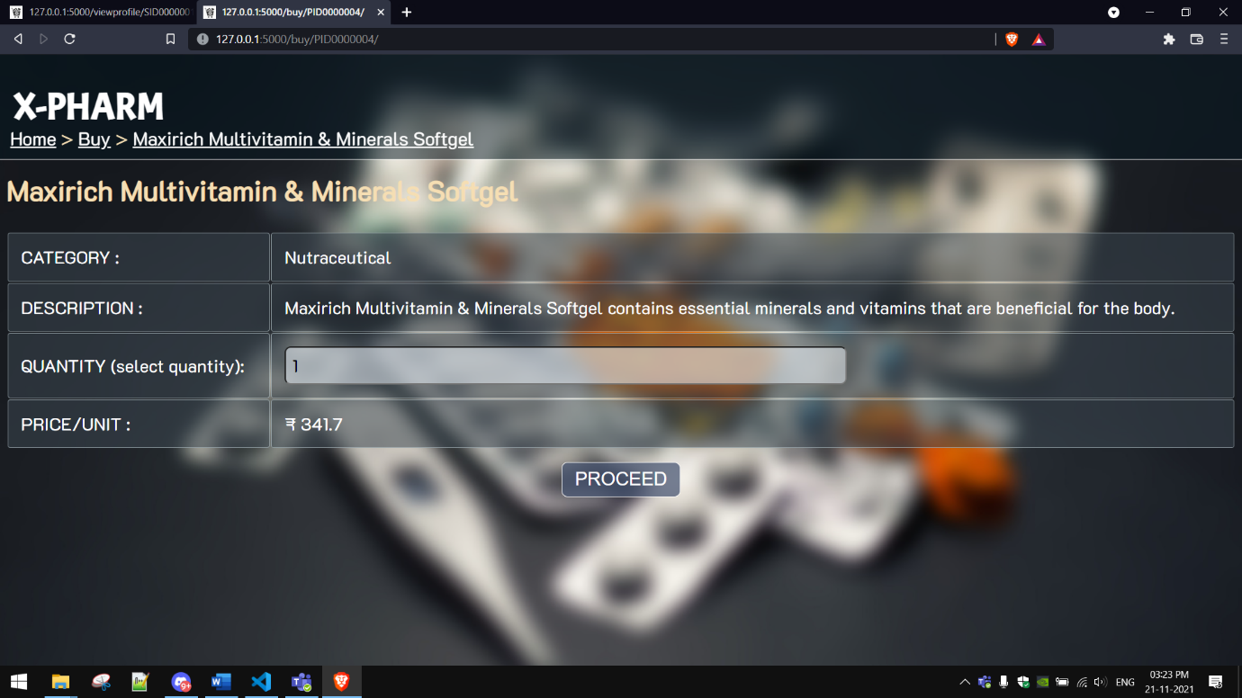

Conclusion: -

Hence After 3 months of the efforts of our entire team collectively, we are happy to announce to you all that our project is finally complete and ready to be released in the market in any possible time.

We Just want to thank Mr. Anuragh Goswami Sir and Mr. Shashank Sir for properly guiding us through this project from the starting, we could not have been more grateful than to have you both as our Mentors.